**KIỂM TRA 45P MÔN HỆ THỐNG CÔNG NGHỆ WEB**

**LỚP LÝ THUYẾT T5 TIẾT 10-12**

**NGÀY 3/3/2022**

Tên:Nguyễn Văn Châu

MSSV: 19494651

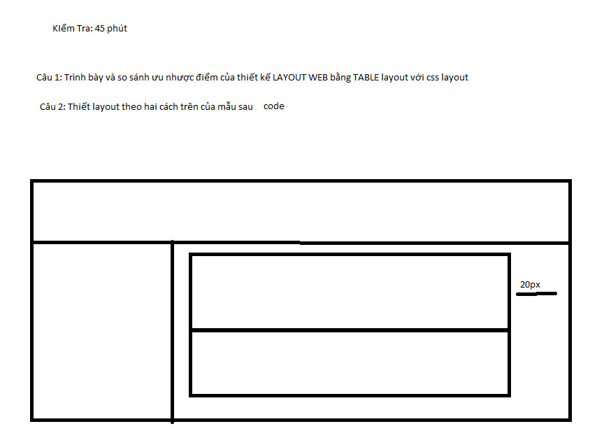

Bài làm:

Câu 1:





Câu 2;

*Css

<!DOCTYPE html>

<html lang="en">

<head>

<meta charset="UTF-8">

<meta http-equiv="X-UA-Compatible" content="IE=edge">

<meta name="viewport" content="width=device-width, initial-scale=1.0">

<title>Document</title>

<style>

.wrapper{

width: 1084px;

}

header{

width: 1084px;

height: 150px;

background-color: hotpink;

}

.content{

width: 100%;

height: 500px;

clear: both;

}

aside{

width: 20%;

height: 100%;

float: left;

background-color: blue;

}

.section_content{

width: 80%;

height: 100%;

float: left;

background-color: green;

}

.section1{

width: 700px;

height:150px;

margin-top: 3rem;

background-color: floralwhite;

margin: 2rem 60px;

}

.section2{

width: 700px;

margin-top: auto;

height:150px;

background-color: yellow;

margin: 2rem 60px;

}

</style>

</head>

<body>

<div class="wrapper">

<header>

</header>

<div class="content">

<aside>

</aside>

<section class="section_content">

<section class="section1"></section>

<section class="section2"></section>

</section>

</div>

</div>

</body>

</html>

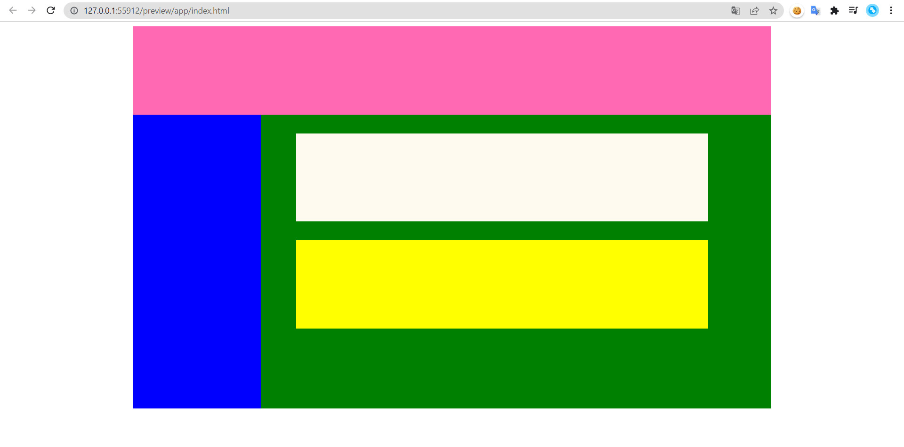

*Table

<!DOCTYPE html>

<html>

<head>

<title>Layout table</title>

</head>

<style>

.top_table{

margin-bottom: 2rem;

height: 150px;

}

.bottom_table{

height: 150px;

}

</style>

<body>

<table border="0" cellpadding="0" cellspacing="0" width="100%">

<tr>

<td>

<table align="center" border="0" cellpadding="0" cellspacing="0" width="900" style="border-collapse: collapse;">

<tr>

<td >

<table border="1" cellpadding="0" cellspacing="0" width="100%" >

<tr>

<td>

<table border="1" cellpadding="0" cellspacing="0" width="100%" >

<tr>

<td width="100%" valign="top" align="center" style="padding: 30px;">

</td>

</tr>

</table>

</td>

</tr>

</table>

</td>

</tr>

<tr>

<td bgcolor="#ffffff">

<table border="1" cellpadding="0" cellspacing="0" width="100%" >

<tr>

<td width="20%" valign="top" align="left" style="padding: 150px 30px; text-align: center;">

</td>

<td width="60%" valign="top" align="center" style="padding: 150px 30px">

<table class="top_table" border="1" cellpadding="0" cellspacing="0" width="100%" >

<tr >

<td width="100%" valign="top" align="center" style="padding: 20px;">

</td>

</tr>

</table>

<table class="bottom_table" border="1" cellpadding="0" cellspacing="0" width="100%" >

<tr>

<td width="100%" valign="top" align="center" style="padding: 20px;">

</td>

</tr>

</table>

</td>

</tr>

</table>

</td>

</tr>

<tr>

</table>

</td>

</tr>

</table>

</body>

</html>

